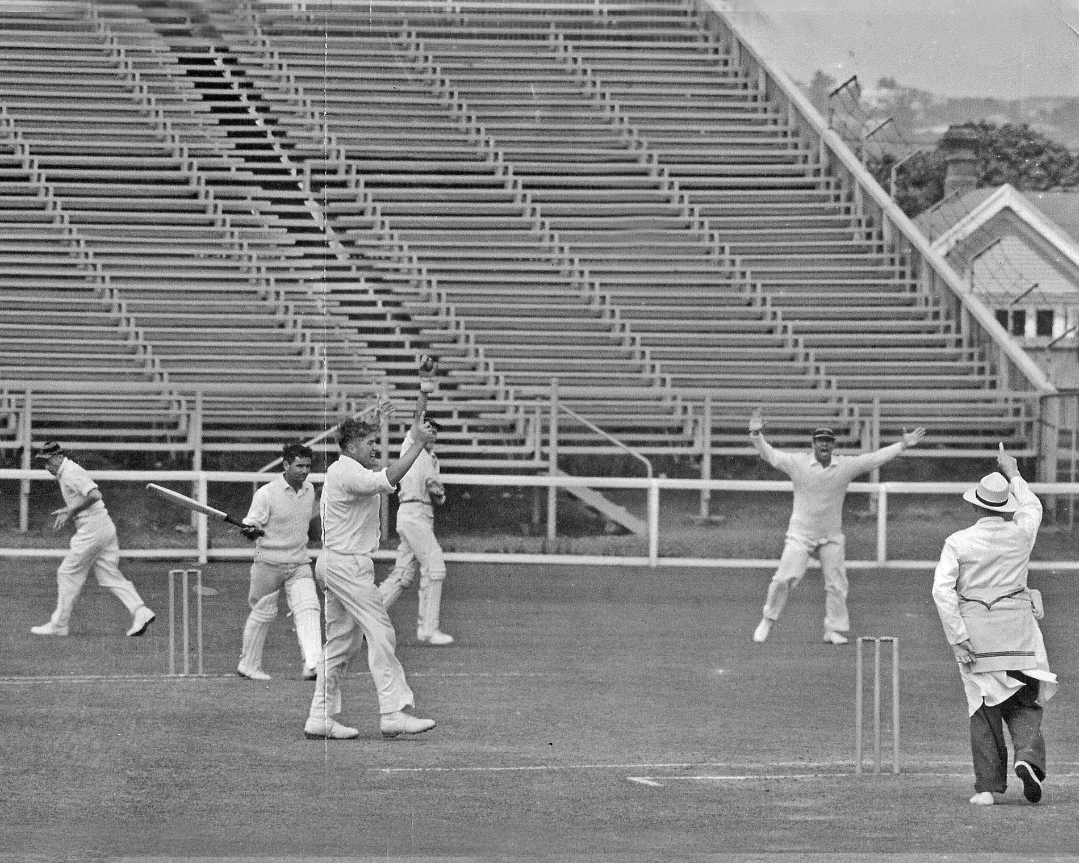

**RC Motz has GE Lowans caght by wicket keeper JT Ward. JW Kiddey and SC Guillen slip fielders**

**Lancaster Park 2 January 1961**

**Central Districts 288 and 157 Canterbury 330 and 116/1. Canterbury won by nine wickets**